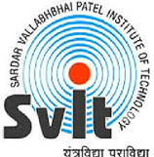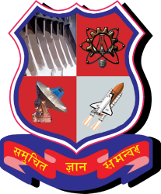

**GUJARAT TECHNOLOGICAL UNIVERSITY**

Ahmedabad, Gujarat, India

Affiliated

Sardar Vallabhbhai Institute of Technology

**CERTIFICATE**

This is to certify that the students namely Priyanka Ghiya(170410107019),Meet Bhavsar(170410107007) ,Aarati Chawda(170410107014),Vatsh Gandhi(170410107018)of ***B.E. (Computer Engineering) Semester IV*** have successfully completed the course work and related tasks for the course of **Design Engineering 1B (2130005)** during the academic term ending in the month of October 2018.

Date: __________

Place: __________

**Prof. Hiren Patel Prof. Neha Soni**

**(Faculty Guide) Head of the Department**

**(External Examiner)**